

**TAYYABA REHMAN**

**49690**

**DATABASE SYSTEM**

**LAB TASK 4**

**TABLES:**

**EVENTS:**

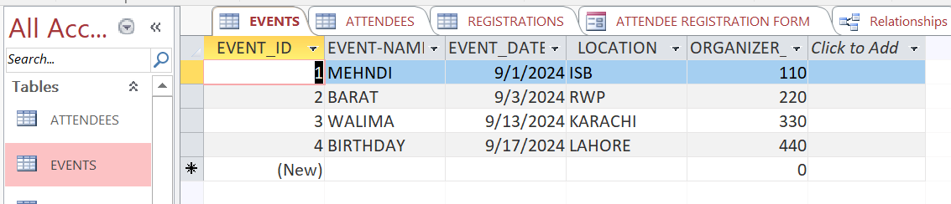

**ATTENDEE:**

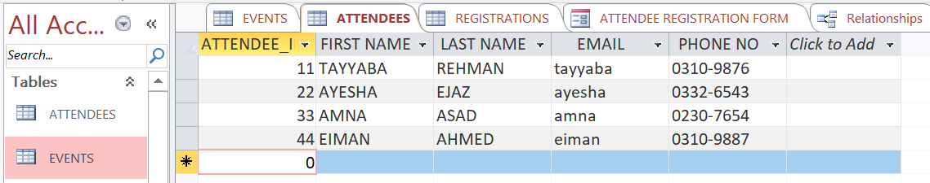

**REGISTRATIONS:**

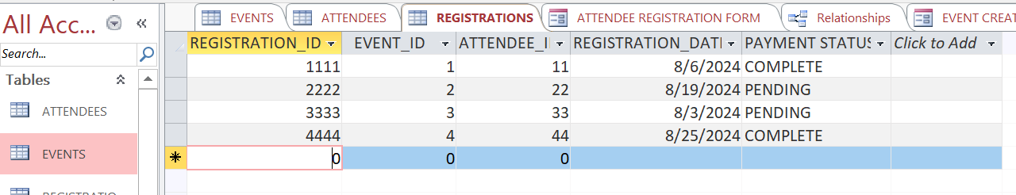

**FORMS:**

**EVENT CREATION FORM:**

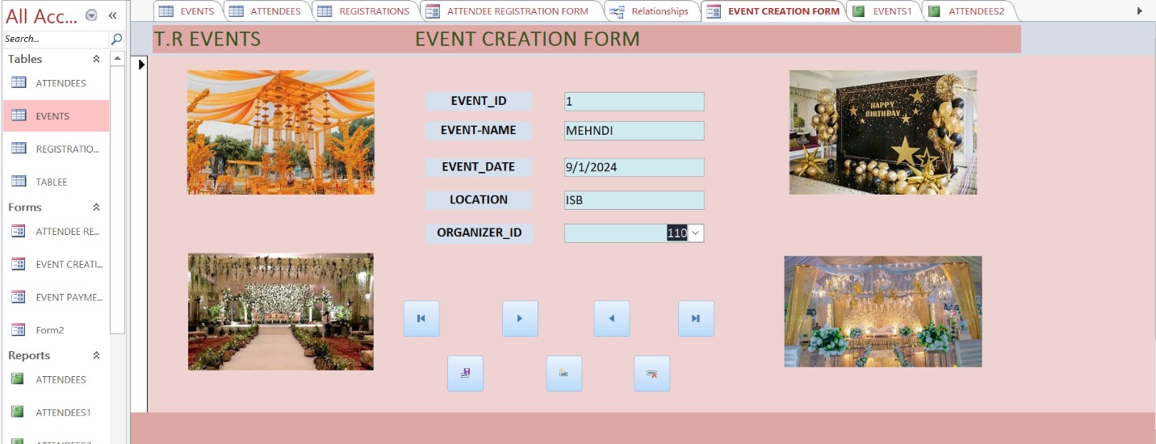

**TABLE VIEW:**

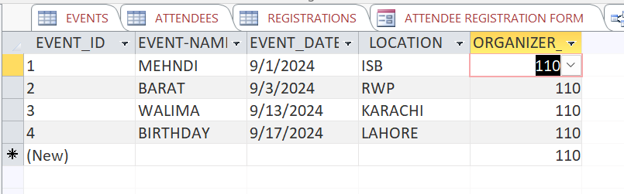

**ATTENDEE REGISTRATION FORM:**

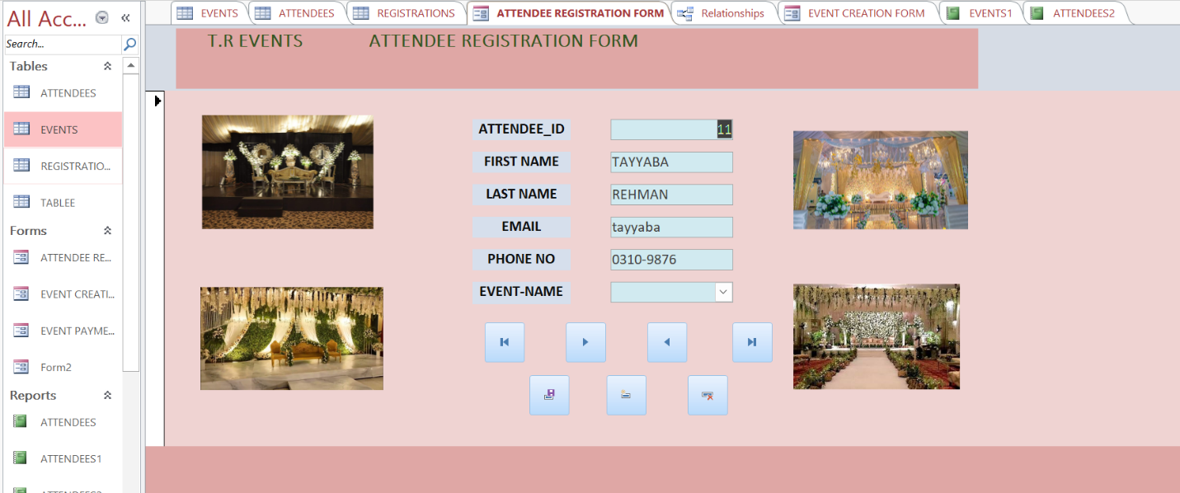

**TABLE VIEW:**

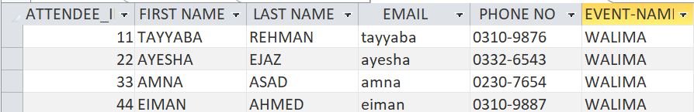

**EVENT PAYMENT FORM:**

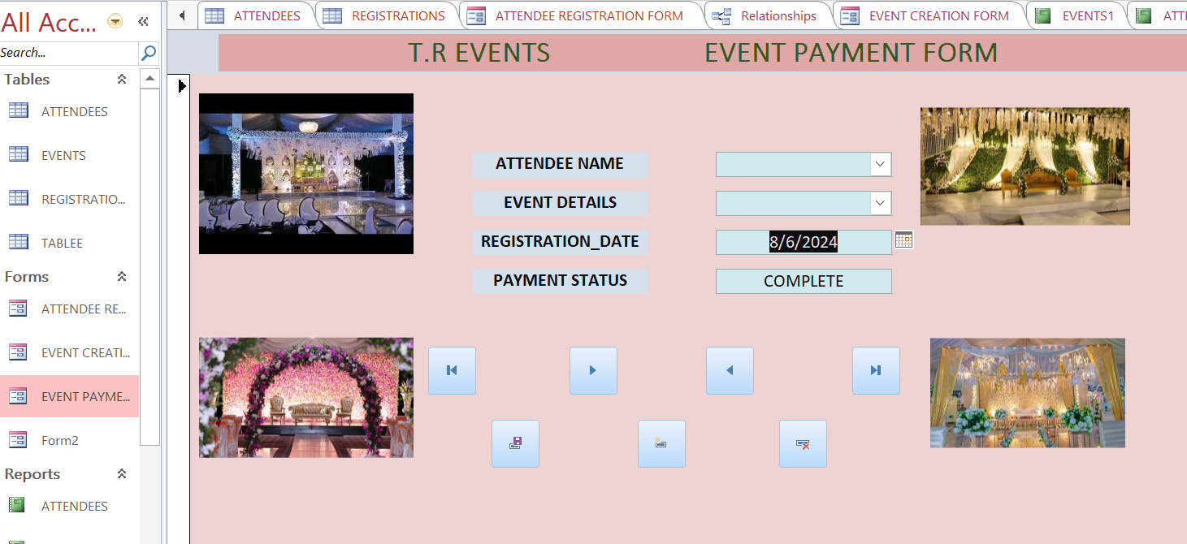

**TABLE VIEW:**

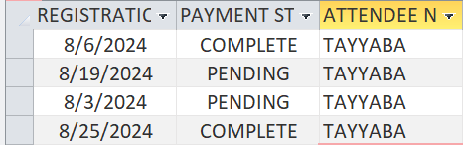

**REPORTS:**

**EVENTS CREATION FORM REPORT:**

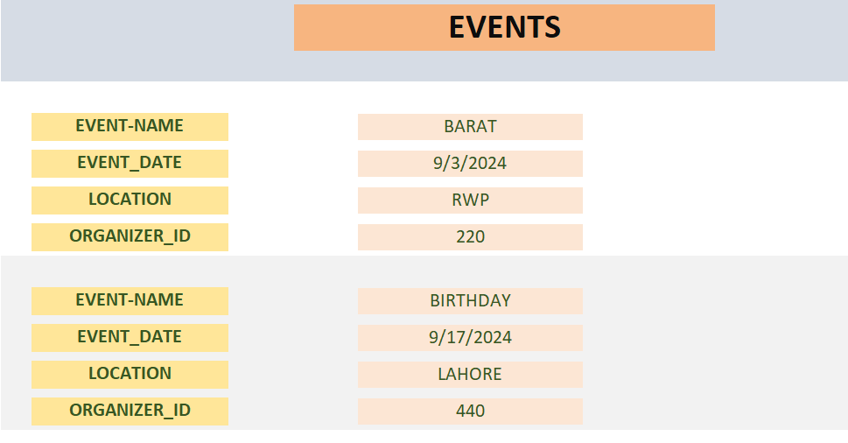

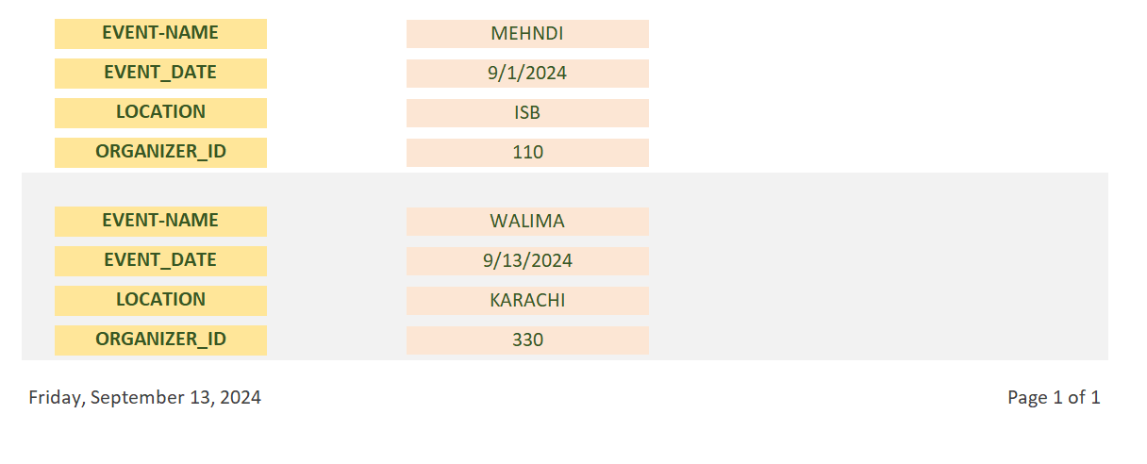

**ATTENDEE REGISTRATION FORM REPORT:**

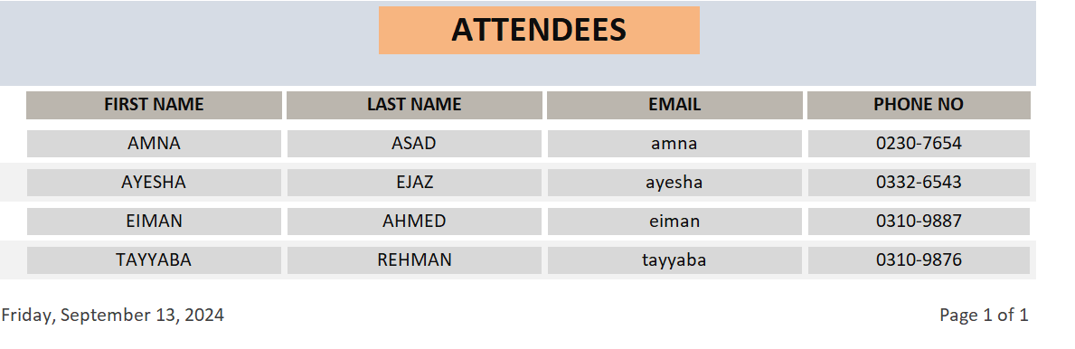

**EVENT PAYMENT FORM REPORT:**

